# **EventPlanLine Database**

Note: I have used MySQL server and MySQL workbench (client application)

1. **Create Statement**

CREATE TABLE EventPlanLine

(

Planno varchar(8) not null ,

Lineno varchar(8) not null,

Timestart datetime not null,

Timeend datetime not null,

Numberfld char(1) not null,

Locno varchar(8) not null,

Resno varchar(8) not null,

CONSTRAINT EventplanlinePK PRIMARY KEY(Planno,Lineno),

CONSTRAINT planoFK FOREIGN KEY(Planno) REFERENCES Eventplan(Planno),

CONSTRAINT locnoFK FOREIGN KEY(Locno) REFERENCES Location(Locno),

CONSTRAINT resnoFK FOREIGN KEY(Resno) REFERENCES ResourceTbl(Resno),

CONSTRAINT ChorologicalCheck CHECK (Timestart < Timeend)

);

Output:

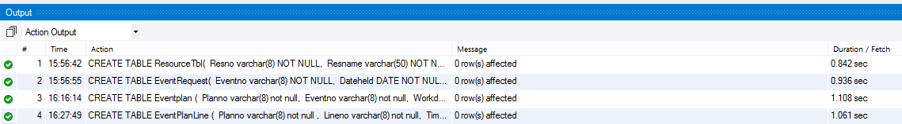

1. **Desc Table**

DESC EventPlanLine;

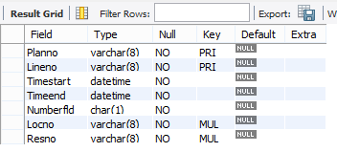

1. **EventPlanLine Table rows**

SELECT * FROM EventPlanLine;

